Parents of the Bride Parents of the Groom
Mr. and Mrs. Last Name Mr. and Mrs. Last Name

Grandparents of the Bride Grandparents of the Groom
Mr. and Mrs. Last Name Mr. and Mrs. Last Name
Mr. and Mrs. Last Name Mr. and Mrs. Last Name

Maid or Matron of Honor
Name……………………………………………Relation of the Bride

Bridesmaids
Name……………………………………………Relation of the Bride
Name……………………………………………Relation of the Bride
Name……………………………………………Relation of the Bride

Personal Attendant
Name……………………………………………Relation of the Bride

Flower Girl
Name……………………………………………Relation of the ????

Best Man
Name…………………………………………....Relation of the Groom

Groomsmen
Name…………………………………………....Relation of the Groom
Name…………………………………………....Relation of the Groom
Name…………………………………………....Relation of the Groom

Ring Bearer
Name……………………………………………Relation of the ????

Ushers
Name……………………………………………Relation of the ????
Name……………………………………………Relation of the ????
Name……………………………………………Relation of the ????
Name……………………………………………Relation of the ????

Altar Servers
Name……………………………………………Relation of the ????
Name……………………………………………Relation of the ????
Name……………………………………………Relation of the ????

Accompanist
Name……………………………………………Relation? Of the ????

Cantor
Name……………………………………………Relation? of the ????

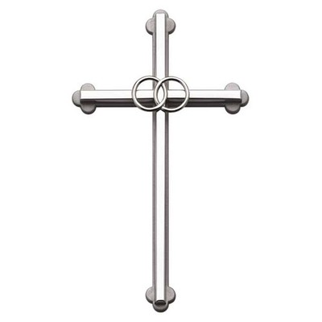

The Nuptial Mass Uniting
(Or “The Wedding Ceremony of”)

Bride’s Full Name
and
Groom’s Full Name

Time of day if you would like

Day of Week, Month, Date, Year

The Church of St. Henry - Perham, Minnesota

Celebrant: Father George Michael or
Father Tom Skaja

Introductory Rites

Prelude (Optional)
Title……………………………………...……………… Composer

Entrance Procession
Title………….....……..………………………………… Composer

Entrance Song (if not the procession)
#### Title……….....……..…………………………..... Composer

Introduction
Gloria
#### Mass Setting…………………………………......Composer

Collect

Liturgy of the Word

First Reading Genesis 2:18-24
Read by Name, relation of the ???

Responsorial Psalm Psalm 34:2-3, 4-5, 6-7, 8-9
Sung by Name, (relation of the ???) “I will bless the Lord at all times.”
Accompanied by Name, (relation of the ???)

Second Reading Ephesians 5:2a, 21-33
Read by Name, relation of the ???

Gospel and Homily Matthew 19:3-6

Celebration of Matrimony

The Consent
Reception of the Consent
Celebrant: “Let us bless the Lord” Congregation: “Thanks be to God”

Blessing and Giving of Rings

Hymn of Praise (Encouraged, but optional)
#### Title……………….…………………...…...…….. Composer

Universal Prayer (Prayer of the Faithful)
Read by Name, relation of the ???

(Optional) We remember Names, who are not able to celebrate with us today.

Liturgy of the Eucharist

Presentation of the Gifts
Presented by Names, relation of the ???
#### Title…..………………………..........…………… Composer

Prayer over the Offerings

Eucharistic Acclamations
Mass Setting………………………………..………….. Composer
#### Holy, Holy, Holy
#### We Proclaim Your Death or When We Eat This Bread
or Save Us Savior
#### Great Amen

The Lord’s Prayer

Nuptial Blessing

Sign of Peace

#### Lamb of God

Distribution of Communion
Title…………..…………………….………….………... Composer

Title…..………........................................................... Composer

Prayer After Communion

The Concluding Rite

Solemn Blessing

Recessional
Title……………………………………………………… Composer

Postlude (Optional)
Title……………………………………………………… Composer

Here would be a good spot for a thank you. And special instructions if any are needed.

You could also extend an invitation (again) to join you for the wedding reception. You could say where it is and give the address again. Let’s be honest, someone probably forgot the invitation and would welcome a reminder.

